1. **Create a number guessing game in android which will be able to suggest whether the number entered by the user is less than the number to be guessed or greater than the number to be guessed. Once the user enters the correct number, it should say “Yu hit the bull’s eye in N attempts”, where N is number of guesses take by user to guess the correct number.**

**xml code**

*<?***xml version="1.0" encoding="utf-8"***?>*<**androidx.constraintlayout.widget.ConstraintLayout xmlns:android="http://schemas.android.com/apk/res/android"  
 xmlns:app="http://schemas.android.com/apk/res-auto"  
 xmlns:tools="http://schemas.android.com/tools"  
 android:layout_width="match_parent"  
 android:layout_height="match_parent"  
 android:background="@drawable/php"  
 tools:context=".MainActivity"**>  
  
 <**TextView  
 android:id="@+id/textView2"  
 android:layout_width="wrap_content"  
 android:layout_height="wrap_content"  
 android:layout_marginStart="20dp"  
 android:layout_marginLeft="20dp"  
 android:text="Guess the Number"  
 android:textSize="45dp"  
 android:textColor="#0D0D0D"  
 app:layout_constraintBottom_toBottomOf="parent"  
 app:layout_constraintLeft_toLeftOf="parent"  
 app:layout_constraintRight_toRightOf="parent"  
 app:layout_constraintStart_toStartOf="parent"  
 app:layout_constraintTop_toTopOf="parent"  
 app:layout_constraintVertical_bias="0.141"** />  
  
  
 <**TextView  
 android:id="@+id/textView"  
 android:layout_width="wrap_content"  
 android:layout_height="wrap_content"  
 android:layout_marginStart="96dp"  
 android:layout_marginLeft="96dp"  
 android:text="Between 1 to 100"  
 android:textSize="30dp"  
 android:textColor="#F10C0C"  
 app:layout_constraintBottom_toBottomOf="parent"  
 app:layout_constraintLeft_toLeftOf="parent"  
 app:layout_constraintRight_toRightOf="parent"  
 app:layout_constraintStart_toStartOf="parent"  
 app:layout_constraintTop_toBottomOf="@+id/textView2"  
 app:layout_constraintVertical_bias="0.055"** />  
  
 <**EditText  
 android:id="@+id/guesset"  
 android:layout_width="300dp"  
 android:layout_height="50dp"  
 android:textColor="#0E0E0E"  
 android:textSize="20dp"  
 app:layout_constraintBottom_toBottomOf="parent"  
 app:layout_constraintEnd_toEndOf="parent"  
 app:layout_constraintHorizontal_bias="0.495"  
 app:layout_constraintStart_toStartOf="parent"  
 app:layout_constraintTop_toBottomOf="@+id/textView"  
 app:layout_constraintVertical_bias="0.333"** />  
  
  
 <**Button  
 android:id="@+id/chkbntn"  
 android:layout_width="250dp"  
 android:layout_height="wrap_content"  
 android:text="CHECK"  
 android:textSize="25dp"  
 android:textColor="#111010"  
 app:layout_constraintBottom_toTopOf="@+id/msgtv"  
 app:layout_constraintEnd_toEndOf="parent"  
 app:layout_constraintStart_toStartOf="parent"  
 app:layout_constraintTop_toBottomOf="@+id/guesset"** />  
  
 <**TextView  
 android:id="@+id/msgtv"  
 android:layout_width="250dp"  
 android:layout_height="23dp"  
 android:textColor="#211F1F"  
 android:textSize="15dp"  
 app:layout_constraintBottom_toBottomOf="parent"  
 app:layout_constraintEnd_toEndOf="parent"  
 app:layout_constraintStart_toStartOf="parent"  
 app:layout_constraintTop_toBottomOf="@+id/guesset"** />  
  
  
</**androidx.constraintlayout.widget.ConstraintLayout**>

**Java code**

**package** com.example.myapplication;  
  
**import** androidx.appcompat.app.AppCompatActivity;  
  
**import** android.os.Bundle;  
**import** android.view.View;  
**import** android.widget.Button;  
**import** android.widget.EditText;  
**import** android.widget.TextView;  
**import** android.widget.Toast;  
  
**import** java.util.Random;  
**public class** MainActivity **extends** AppCompatActivity **implements** View.OnClickListener {  
  
 EditText **guess**;  
 **private static final int *MAX_NUMBER*** = 100;  
 **public static final** Random ***r*** = **new** Random();  
 TextView **msg**;  
 Button **chkbtn**;  
 **private int number** , **tries**;  
  
 @Override  
 **protected void** onCreate(Bundle savedInstanceState) {  
 **super**.onCreate(savedInstanceState);  
 setContentView(R.layout.***activity_main***);  
  
 **msg** = findViewById(R.id.***msgtv***);  
 **chkbtn**= findViewById(R.id.***chkbntn***);  
 **guess** = findViewById(R.id.***guesset***);  
 **chkbtn**.setOnClickListener(**this**);  
  
 newGame();  
  
 }  
  
 @Override  
 **public void** onClick(View v) {  
 **if** (v == **chkbtn**)  
 validate();  
  
 }  
  
 **private void** validate() {  
 **int** n = Integer.*parseInt*(**guess**.getText().toString());  
 **tries**++;  
  
 **if**(n == **number**)  
 {  
 Toast.*makeText*(**this**,**"you hit the bulls eye "**+**number**+**" in "**+**tries**+**" attempts"**,Toast.***LENGTH_LONG***).show();  
 newGame();  
 }  
 **else if**(n > **number**)  
 {  
 **msg**.setText(**"It is Greater"**);  
 }  
 **else if**(n < **number**)  
 {  
 **msg**.setText(**"It is Lower"**);  
 }  
  
 }  
 **private void** newGame() {  
  
 **number** = ***r***.nextInt(***MAX_NUMBER***)+1;  
 **guess**.setText(**""**);  
 **msg**.setText(**""**);  
 **tries** = 0;  
 }  
 }

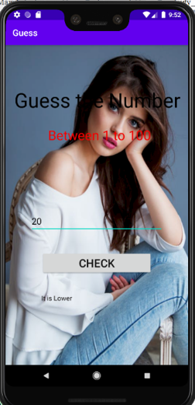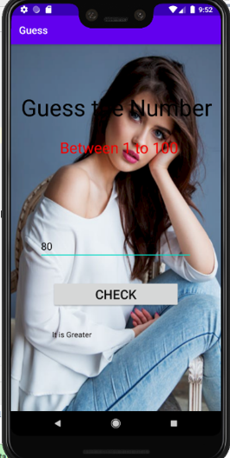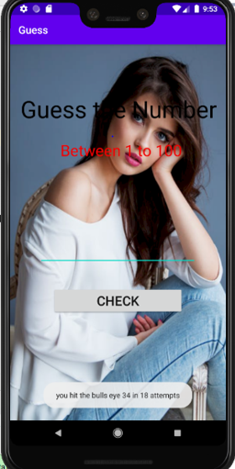**OUTPUT :-**